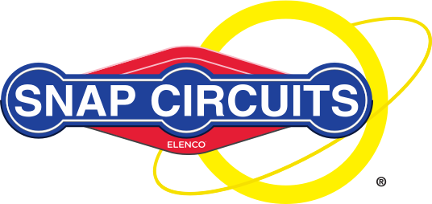

SNAP CIRCUITS PROGRAM!
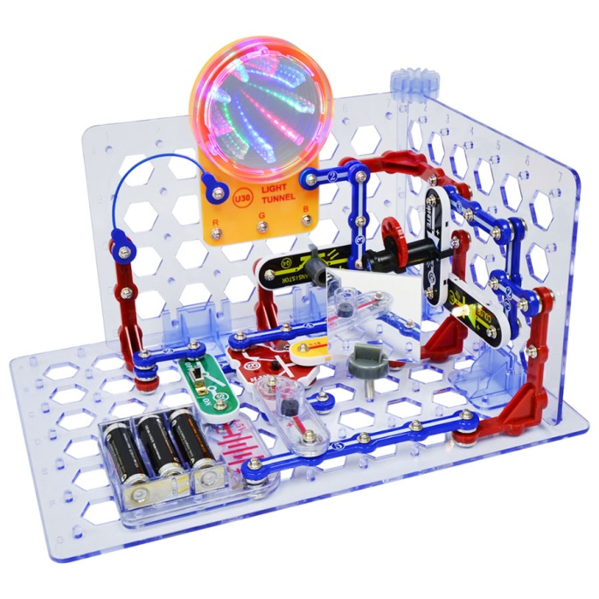
MARCH 22ND – 4PM-6PM
This hands on, come and go as you please program will let you try out this fun and informative game!

Everyone will get the chance to try their hand at using these circuits to make fun and interesting designs and effects including sirens, light shows and 3D tunnels!
AGES 10 AND UP

